• Activity: • Test a spring pet clinic application using Jenkins • Steps: • Create a Freestyle project and name it as PetClinicTest • Provide the repository path in Source Code Management section : https://github.com/AnjuMeleth/spring-petclinic.git • Select “Invoke top level maven target” under “Build” section. Set the goal as “test” under the correct installation • Save the configuration and Build Now • Definition of Done: • Upload the screenshot of Jenkins dashboard -> console Output to the GitHub under the folder Task11

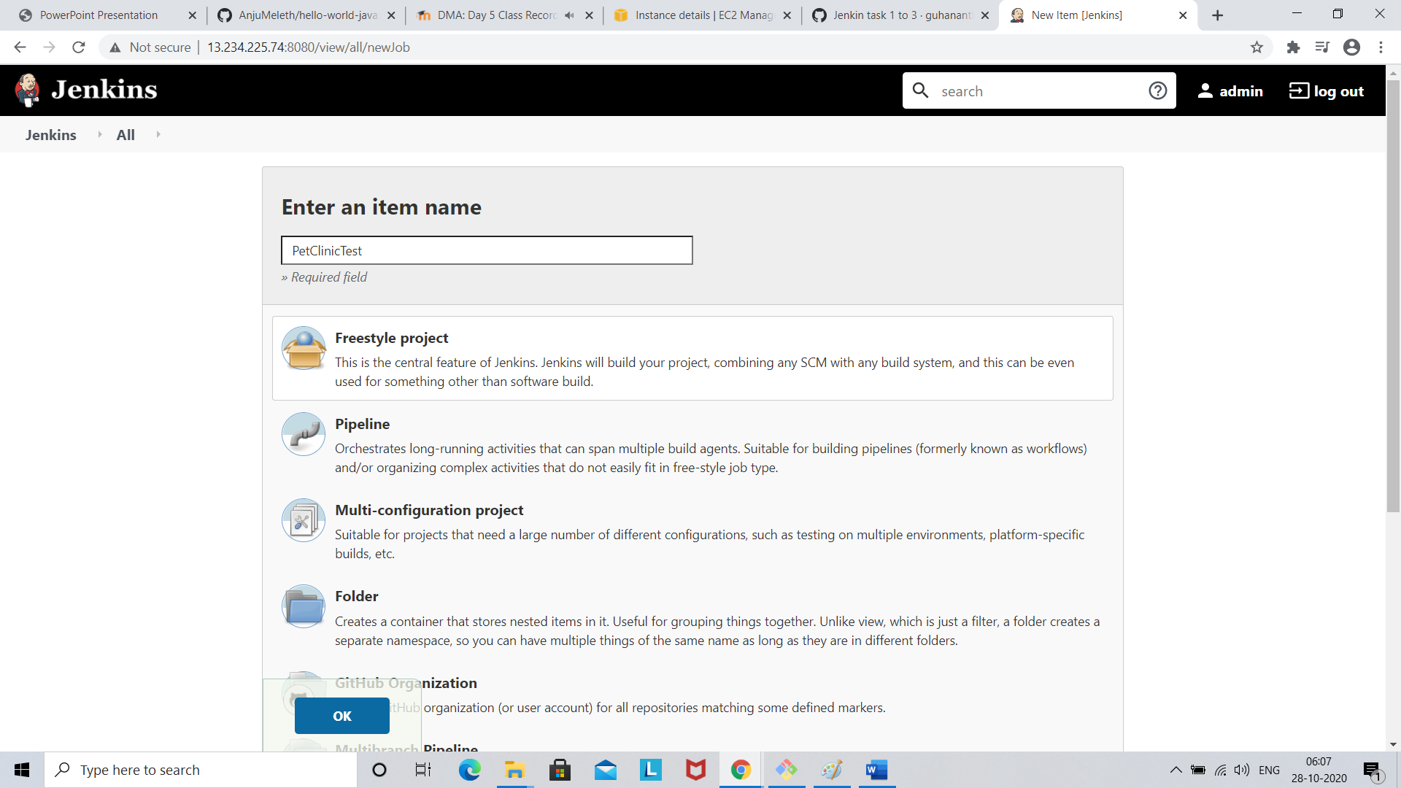

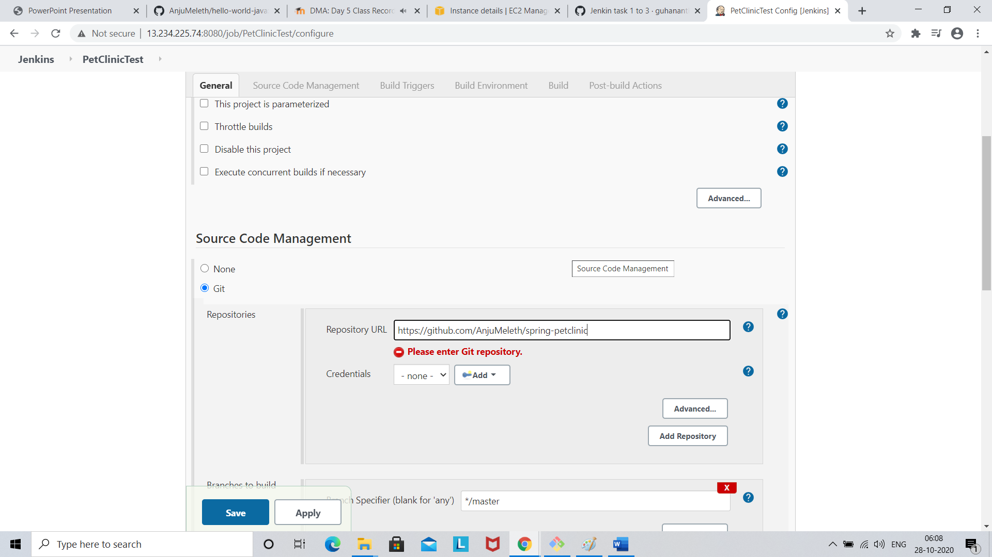

Click save

Go to build tab

